PIR датчик
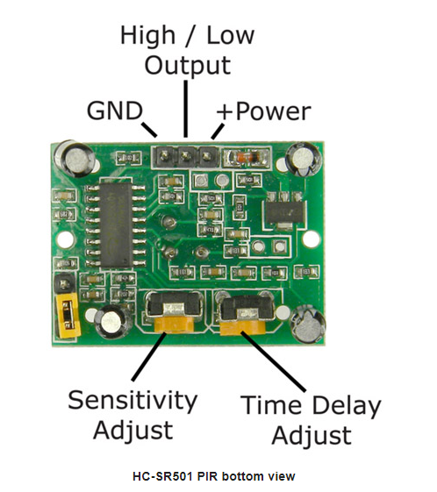 | 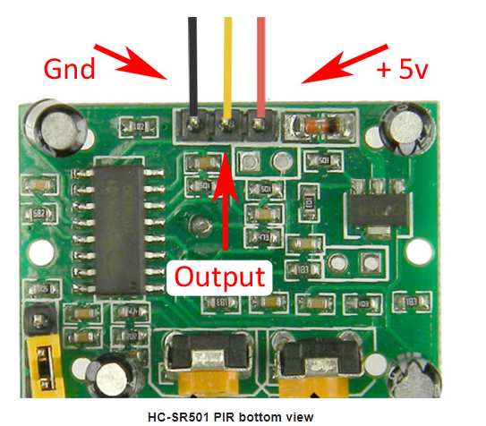

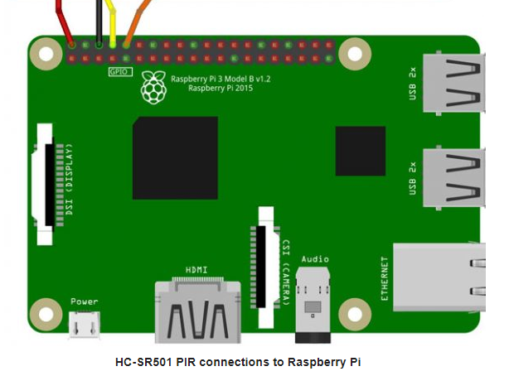

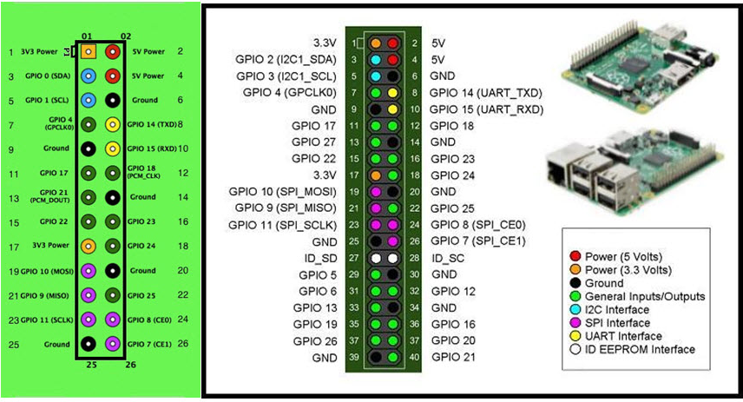
Код на Python
# MBTechWorks.com 2017
# Use an HC-SR501 PIR to detect motion (infrared)

#!/usr/bin/python

import RPi.GPIO as GPIO
import time

GPIO.setmode(GPIO.BOARD) #Set GPIO to pin numbering
pir = 8 #Assign pin 8 to PIR
led = 10 #Assign pin 10 to LED
GPIO.setup(pir, GPIO.IN) #Setup GPIO pin PIR as input
GPIO.setup(led, GPIO.OUT) #Setup GPIO pin for LED as output
print ("Sensor initializing . . .")
time.sleep(2) #Give sensor time to startup
print ("Active")
print ("Press Ctrl+c to end program")

try:
while True:
if GPIO.input(pir) == True: #If PIR pin goes high, motion is detected
print ("Motion Detected!")
GPIO.output(led, True) #Turn on LED
time.sleep(4) #Keep LED on for 4 seconds
GPIO.output(led, False) #Turn off LED
time.sleep(0.1)

except KeyboardInterrupt: #Ctrl+c
pass #Do nothing, continue to finally
finally:
GPIO.output(led, False) #Turn off LED in case left on
GPIO.cleanup() #reset all GPIO
print ("Program ended")

Установка Pygame
sudo apt-get install python-pip
sudo pip install pygame
Обновление системы
apt-get update
apt-get upgrade

Запуск аудиофайла
import pygame
pygame.mixer.init()
pygame.mixer.music.load("myFile.wav")
pygame.mixer.music.play()
while pygame.mixer.music.get_busy() == True:
continue

